Group POGS
ST 599
Very tentative graphic for question of interest:

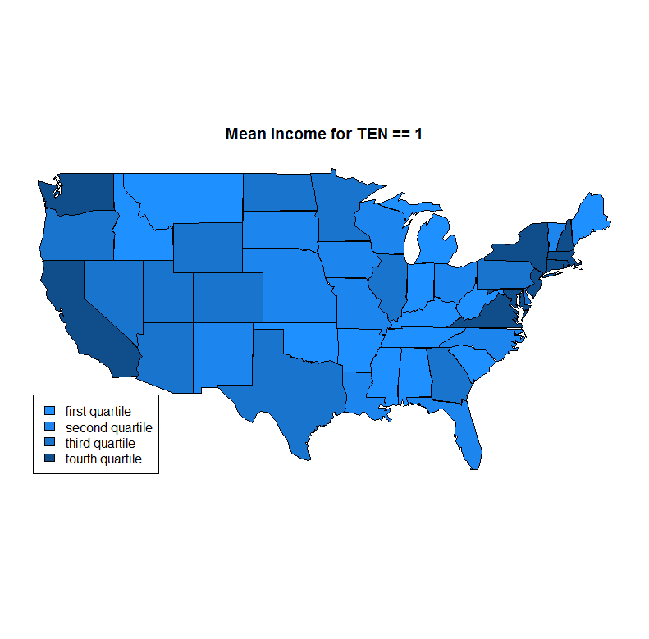

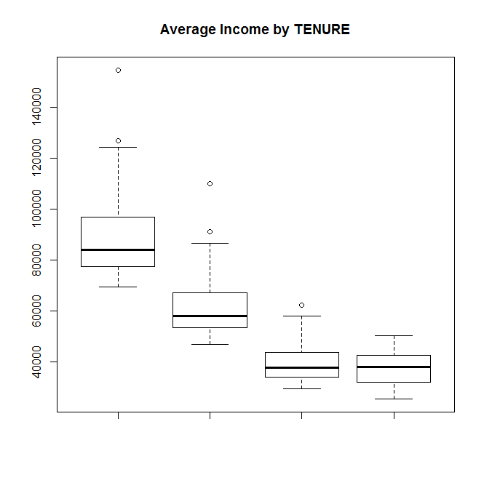
Task:
3 Questions from each by 7pm on Tuesday 4/8/14 re: ACS
(Class deadline: 9am Wednesday 4/9/14, 3 per group)
- Jasmine’s Questions:
  - Is there any evidence that the mean household income differs for ***insert interesting comparison here***, after accounting for other key variables
    - Is there any evidence that the mean household income differs for the different modes of transportation to and from work?
    - Is there any evidence that the mean household income differs between households that own or rent a unit.
    - There is data on selected housing characteristics specifically lacking complete plumbing facilitates, lacking complete kitchen facilities and no telephone service. Is there any evidence that the mean household income differs for the different lacking amenities?
  - What are factors contributing to unemployment?
  - Difference of health insurance coverage between (can look at one or all)
    - Males vs. females
    - Age
    - Different types of jobs (private, government, self-employed, unemployed)
    - Occupation
    - Education attainment
    - Married vs. never married
    - Number of children
- Andy’s Questions:
  - Does Item nonresponse vary by demographics (state, age, gender, race, income... Q3-6, 47). Item nonresponse means someone filled out the questionnaire but skipped a particular question.
    - I like this question because it is an ugly, ugly multiple comparison problem (lots of items to skip, lots of demographic categories to consider) so I think it gets to at least one interesting general concern in analyzing "big data".
  - Are there patterns in the number of same-sex couples (reporting "husband or wife" or "unmarried partner" in Q2 and of the same gender in Q3) across states, particularly compared to those states' stance on same sex marriage?
    - I like this one because it's very topical and I'm curious; it would be an easy thing to tell people about when they ask me variations on "what can you do with statistics?"
  - What do we know about bike commuters? (Q31 pegs bicycle commuters: might look at income, age, race, gender, job status, citizenship...)
    - I like this one because I love my own bike commute and would like to know more about bike commuters in general.
- Sarah’s Questions:
  - Who are the mobile people?
    - Did not live in the same house 1 year ago.
    - Could compare within/between states, how many move from abroad?
    - Which areas have the greatest influx? Which areas have the greatest outflux? (Could see either growth of urban areas or some smaller towns becoming big cities)
  - How does income correlate with education?
    - Level of education?
    - Field of bachelor degree for those with one?
    - Place currently living?
  - The cost of utilities (especially water) correlated with location. I don't believe we can use additional data like days of sunshine or average temperature or precipitation, but I just heard that the NSA has a data center in Utah (http://en.wikipedia.org/wiki/Utah_Data_Center), which they built there because they were guaranteed lower water costs. Utah is a pretty dry place, and they use a significant amount of water for cooling. It's a little bit off topic, but it piqued my curiosity.
- Tim’s Questions:
  - How do the proportions of people using some kind of solar energy
differ state to state (p.6 Question 13)?
  - Does the proportion of head of households that speak something
other than English at home differ between states (page 8 question 14)?
  - Of those heads of households that have been married, does the
proportion that have been married only once differ by state? Twice?
More than three times? (p.9 question 22)

